# Informações do estudo

Referência: Laouissi (CC6090)

Grandeza: Rugosidade

Tipo: Ra

Material: EN-GJL-250 cast iron

Ferramenta: CC6090

Número de experimentos: 27

Observações:  
Workpiece: 80mm in diameter and 400mm in length  
Lathe: TOS TRENCIN-SN40C  
Dynanometer: KISTLER  
Tool holder: CSDNN25x25M12  
Roughness meter: Mitutoyo surftest-201

# Unidades

Velocidade: m/min

Avanço: mm/rev

Profundidade de corte: mm

Rugosidade: μm

# Dados de teste

|  |  |  |  |
| --- | --- | --- | --- |
| Rugosidade | n | f | a |
| 0.72 | 530.0 | 0.08 | 0.25 |
| 1.58 | 370.0 | 0.2 | 0.75 |
| 1.18 | 530.0 | 0.2 | 0.25 |
| 1.29 | 260.0 | 0.14 | 0.25 |
| 0.77 | 370.0 | 0.08 | 0.25 |
| 0.91 | 370.0 | 0.14 | 0.25 |

# Dados de treino

|  |  |  |  |
| --- | --- | --- | --- |
| Rugosidade | n | f | a |
| 1.53 | 260.0 | 0.2 | 0.25 |
| 1.06 | 530.0 | 0.14 | 0.75 |
| 1.35 | 260.0 | 0.14 | 0.5 |
| 1.39 | 370.0 | 0.2 | 0.25 |
| 1.27 | 530.0 | 0.2 | 0.5 |
| 0.71 | 530.0 | 0.08 | 0.75 |
| 0.88 | 370.0 | 0.14 | 0.5 |
| 1.79 | 260.0 | 0.2 | 0.75 |
| 1.78 | 260.0 | 0.2 | 0.5 |
| 0.83 | 530.0 | 0.14 | 0.25 |
| 0.79 | 530.0 | 0.14 | 0.5 |
| 0.75 | 260.0 | 0.08 | 0.5 |
| 1.31 | 260.0 | 0.14 | 0.75 |
| 0.85 | 370.0 | 0.08 | 0.75 |
| 0.82 | 260.0 | 0.08 | 0.25 |
| 1.43 | 370.0 | 0.2 | 0.5 |
| 0.73 | 370.0 | 0.08 | 0.5 |
| 0.7 | 530.0 | 0.08 | 0.5 |
| 1.4 | 530.0 | 0.2 | 0.75 |
| 1.21 | 370.0 | 0.14 | 0.75 |
| 0.93 | 260.0 | 0.08 | 0.75 |

# RN

Número de neurônios: 53

Taxa de aprendizado: 1.000000e-03

Número de épocas: 498

2° camada: False

Função de ativação: relu

# Erros

**Dados de teste**

* Erro relativo médio: 6.93
* Coeficiente de correlação: 0.96
* Coeficiente de determinação: 0.93
* MSE: 0.01
* RMSE: 0.1

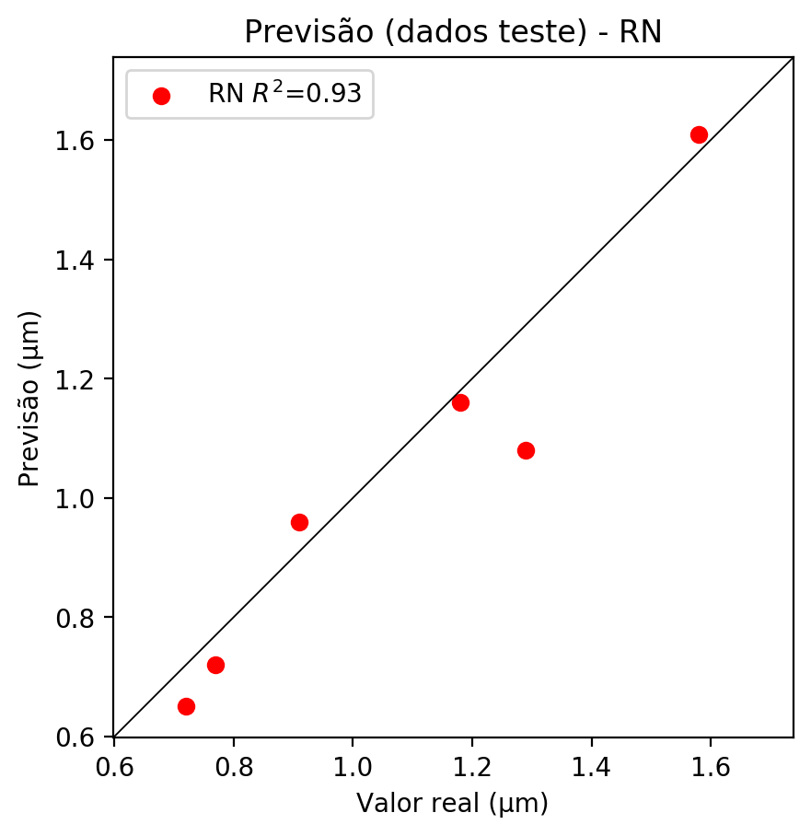

**Dados de treino**

* Erro relativo médio: 2.81
* Coeficiente de correlação: 0.99
* Coeficiente de determinação: 0.98
* MSE: 0.0
* RMSE: 0.0

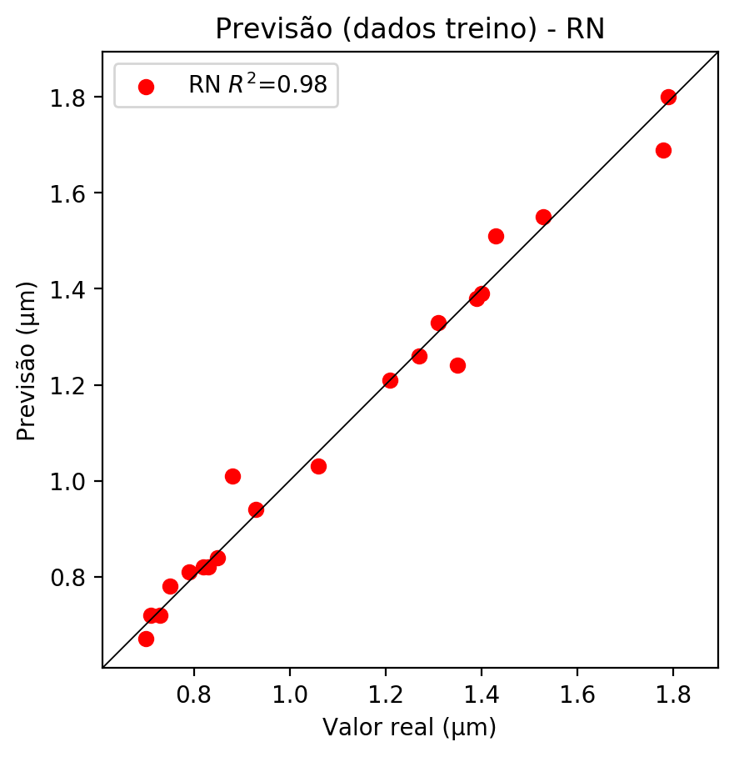

# Pesos

Pesos - camada oculta 1

[[ 0.10827951 0.0083092 -0.10352284 -0.27877828 0.08084582 0.03797428  
 0.16037156 -0.2660917 0.07553715 0.03144668 -0.16018084 -0.02361307  
 0.02058913 0.24589136 -0.05408029 0.07153361 0.00785976 0.04536069  
 -0.14941819 0.15823926 0.17948407 0.09679946 0.16837348 0.02749302  
 -0.14033234 -0.1078843 0.19377425 -0.17266662 0.1349353 -0.10997702  
 0.24826999 -0.20756137 -0.05994451 -0.12446183 0.13118024 -0.1191156  
 -0.14858092 0.05872912 -0.12163443 0.12230684 0.01464201 0.07336975  
 0.16913408 0.1799873 -0.03311079 -0.3460056 0.23178035 -0.07847851  
 0.1617079 0.17138638 0.0949981 0.10326321 0.01005185]  
 [-0.0317742 -0.09183567 -0.02057115 0.3238099 0.06734833 -0.3618136  
 -0.3831565 0.48348334 -0.321922 -0.20875871 -0.0383402 0.4998465  
 -0.25022566 -0.04109016 0.01647992 -0.3370575 -0.13306145 -0.11785374  
 -0.07426718 0.0328473 -0.17440133 0.21497773 -0.23709925 0.22538261  
 0.27188933 -0.04132992 -0.04086407 0.41075343 -0.253383 -0.3866149  
 -0.02877443 -0.21837607 0.17312005 -0.09985169 -0.20534007 -0.39032474  
 0.45540234 -0.06951287 -0.32754552 -0.37818012 0.19215289 -0.06130381  
 -0.15885073 -0.24517675 0.20871986 0.29330036 -0.10235526 0.03117024  
 -0.12254041 0.40011516 -0.16482991 -0.21713069 -0.21170056]  
 [-0.09459314 -0.18701963 0.01766868 0.38084036 -0.0334905 -0.1931874  
 0.40969685 0.4935827 0.24443543 0.25359467 -0.05402408 -0.01896003  
 -0.1423765 0.04635765 -0.00642004 -0.23081103 -0.04789099 -0.12307465  
 0.1529847 -0.04872103 0.16613236 -0.13092014 -0.2735659 -0.15634222  
 -0.08986947 -0.00649857 -0.03829951 0.32985646 0.20518045 0.27485177  
 0.0565522 0.04285925 -0.27289957 0.11608887 -0.26648188 -0.24924783  
 0.15844534 -0.10701157 0.04898076 -0.07983139 0.34845087 0.05753022  
 0.15485184 0.07253901 0.35585195 -0.31962568 0.17423628 0.00211862  
 -0.26084727 -0.365956 0.16511714 0.17391492 0.09087478]]

Bias - camada oculta

[-0.10150469 -0.04185576 -0.11606781 0.17850196 -0.10875613 0.18403673  
 0.22972833 0.18572965 0.17709047 -0.06777326 -0.14861171 -0.00356269  
 -0.06798457 0.32514164 -0.09328597 0.1945762 -0.05184032 0.09030025  
 -0.15517043 -0.12059505 -0.09257326 -0.08009125 0.2625567 -0.05202935  
 -0.02070134 -0.12097938 -0.11738602 0.16928796 -0.09528768 0.04919948  
 0.31303626 -0.13602413 -0.1049266 -0.1395679 0.15350443 0.04342201  
 0.16314381 -0.07494103 0.01969013 0.18141495 -0.01843883 -0.08120625  
 -0.09021264 -0.102824 -0.00484519 -0.03559797 0.34396854 -0.12854826  
 -0.09550602 -0.04628328 -0.09159385 -0.09324785 -0.04885192]

Pesos - camada saída

[[ 0.12846331 0.01938666 -0.14734928 0.28928527 0.10385601 -0.27452457  
 -0.16973248 0.24861166 -0.23638299 0.04165874 -0.21433982 0.40319192  
 0.05094375 -0.34272182 -0.0826078 -0.3024266 0.0280731 -0.0803771  
 -0.17423703 0.18506117 0.19914465 0.09642795 -0.28198424 0.09057597  
 0.09023173 -0.15321222 0.22539318 0.32259288 0.16427612 -0.15349798  
 -0.34366664 -0.19135764 -0.08074073 -0.15851991 -0.07206652 0.06387099  
 0.3298016 0.08027883 -0.01502754 -0.22494611 0.1372655 0.09234974  
 0.19229639 0.21356812 0.17593937 0.24880081 -0.19459614 -0.12338712  
 0.1818026 0.14078379 0.12520178 0.13096811 0.01123961]]

# Iterações

|  |  |  |  |  |  |  |
| --- | --- | --- | --- | --- | --- | --- |
| Média | Desvio | n | ln | 2° camada | Função | Épocas |
| -0.1392 | 0.1446 | 10 | 0.1 | False | relu | 38 |
| -0.1381 | 0.1245 | 17 | 0.1 | True | relu | 716 |
| -0.1475 | 0.1152 | 7 | 0.01 | True | tanh | 130 |
| -0.3148 | 0.1918 | 19 | 0.001 | False | tanh | 282 |
| -0.1479 | 0.1192 | 29 | 0.001 | False | relu | 469 |
| -0.3046 | 0.1941 | 88 | 0.1 | False | tanh | 926 |
| -0.1411 | 0.1193 | 95 | 0.0001 | True | relu | 984 |
| -0.2449 | 0.1966 | 10 | 0.01 | True | tanh | 865 |
| -0.7799 | 0.5303 | 58 | 0.001 | True | relu | 8 |
| -0.238 | 0.1353 | 9 | 0.01 | False | tanh | 514 |
| -0.1145 | 0.1118 | 73 | 0.0001 | True | relu | 729 |
| -0.1198 | 0.0834 | 22 | 0.001 | True | relu | 543 |
| -0.1786 | 0.1239 | 25 | 0.1 | True | relu | 562 |
| -0.1082 | 0.0964 | 53 | 0.001 | False | relu | 498 |
| -0.1631 | 0.1274 | 83 | 0.01 | True | relu | 337 |
| -0.4448 | 0.2555 | 99 | 0.01 | False | tanh | 16 |
| -0.2179 | 0.1411 | 23 | 0.01 | False | relu | 472 |
| -0.2253 | 0.1885 | 24 | 0.001 | True | relu | 778 |
| -0.2998 | 0.1909 | 58 | 0.01 | True | tanh | 382 |
| -0.3556 | 0.2028 | 35 | 0.1 | False | tanh | 596 |

# RL

# Coeficientes

[ 0. -0.40011377 0.91749338 0.25199138]

# Erros

**Dados de teste**

* Erro relativo médio: 13.63
* Coeficiente de correlação: 0.95
* Coeficiente de determinação: 0.91
* MSE: 0.02
* RMSE: 0.14

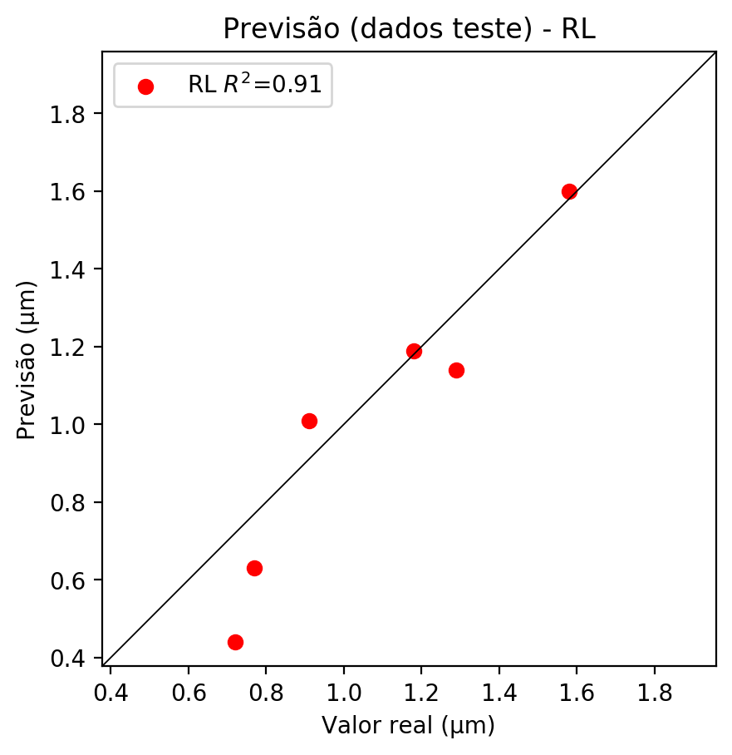

**Dados de treino**

* Erro relativo médio: 6.69
* Coeficiente de correlação: 0.97
* Coeficiente de determinação: 0.93
* MSE: 0.01
* RMSE: 0.1

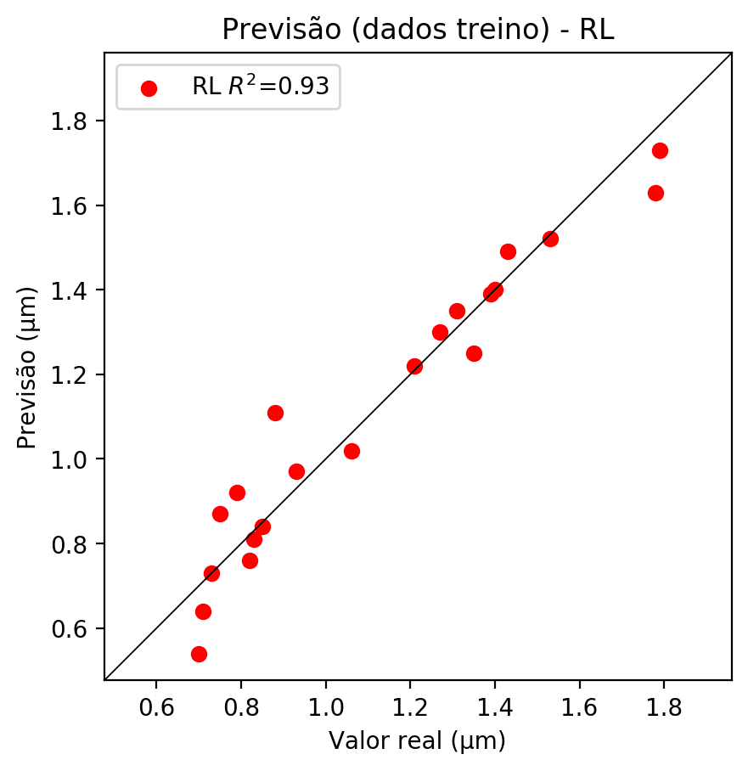

# RP2

# Coeficientes

[ 0. -0.40964119 0.88435153 0.24199878 0.11701759 -0.13459017  
 0.00841363 0.11723111 0.05811611 0.06539311]

# Erros

**Dados de teste**

* Erro relativo médio: 8.49
* Coeficiente de correlação: 0.98
* Coeficiente de determinação: 0.96
* MSE: 0.01
* RMSE: 0.1

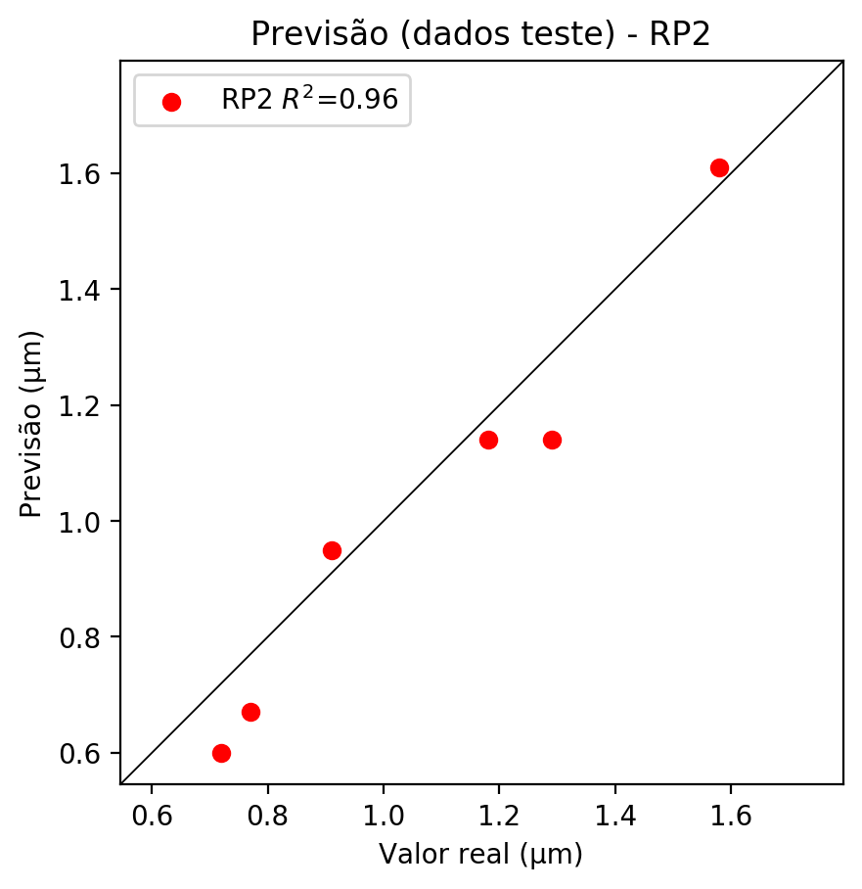

**Dados de treino**

* Erro relativo médio: 5.17
* Coeficiente de correlação: 0.98
* Coeficiente de determinação: 0.96
* MSE: 0.0
* RMSE: 0.0

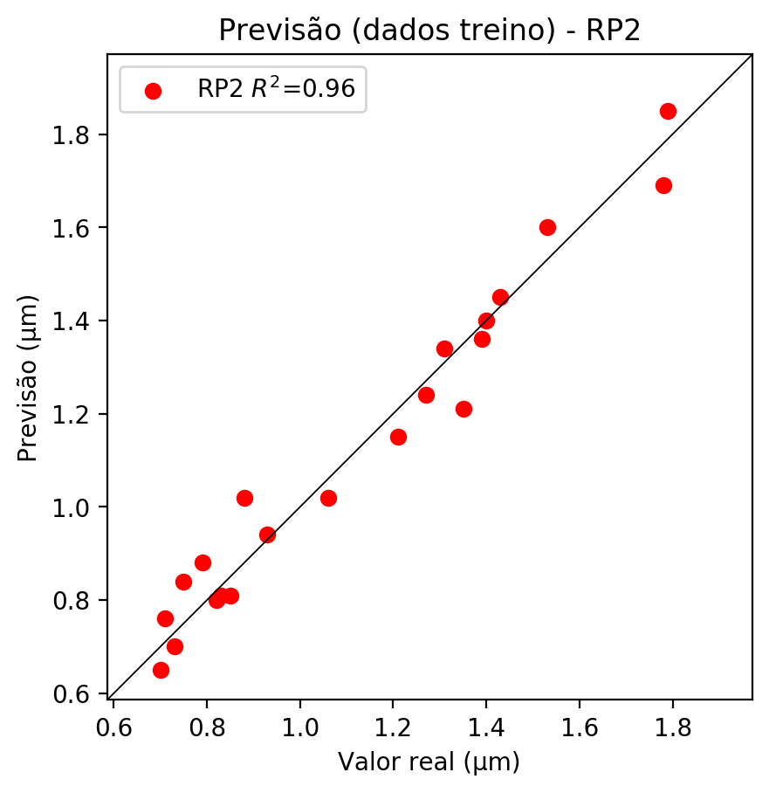

# RP3

# Coeficientes

[ 0. -0.18414326 0.27559133 0.12295346 0.15213308 -0.19651434  
 -0.11556394 0.25326822 0.12426383 0.11768268 -0.2659847 0.07995666  
 -0.0154558 0.10375384 0.06525424 0.16246011 0.39807636 -0.22025842  
 -0.12761311 0.17759944]

# Erros

**Dados de teste**

* Erro relativo médio: 17.21
* Coeficiente de correlação: 0.77
* Coeficiente de determinação: 0.59
* MSE: 0.04
* RMSE: 0.2

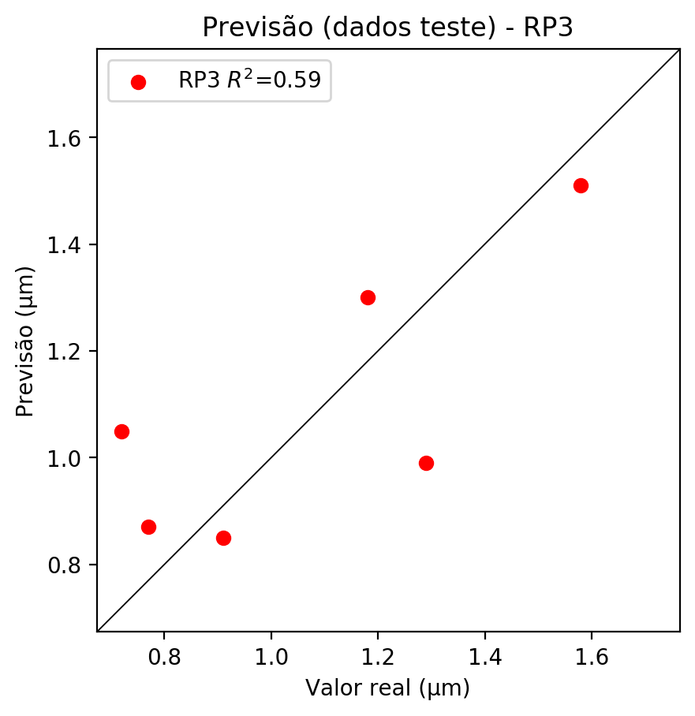

**Dados de treino**

* Erro relativo médio: 3.49
* Coeficiente de correlação: 0.99
* Coeficiente de determinação: 0.98
* MSE: 0.0
* RMSE: 0.0

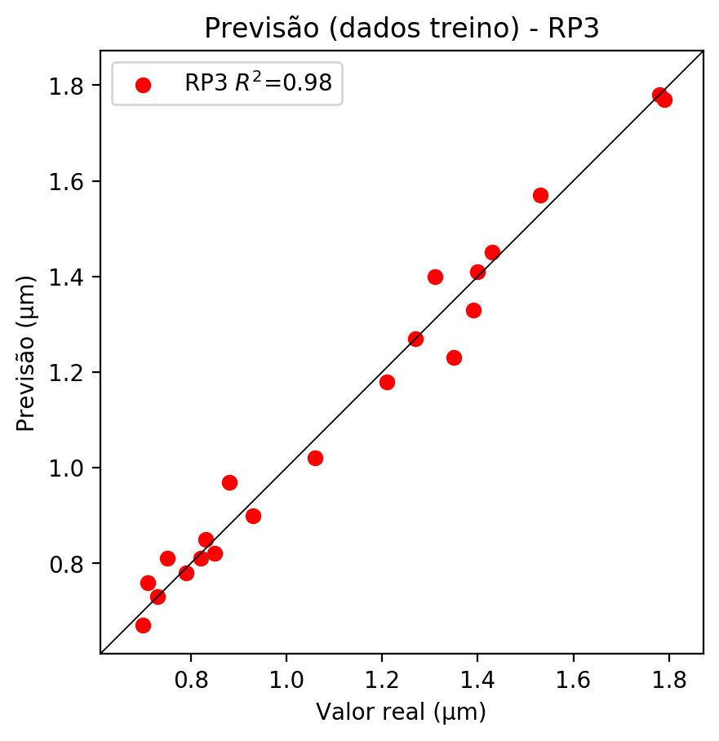

# RP4

# Coeficientes

[-4.44089210e-16 -2.60181414e-01 2.64032325e-01 7.59338113e-02  
 1.90797008e-01 -6.40586032e-02 2.73483237e-02 1.45262004e-01  
 8.11221442e-02 1.66454589e-01 -3.75817598e-01 1.25093532e-01  
 -1.09593359e-01 2.72684911e-01 -7.68571982e-02 1.76767705e-01  
 3.81380025e-01 -5.55512547e-02 2.75553288e-02 1.09682172e-01  
 2.20984693e-01 -3.71098182e-02 5.54413220e-02 -2.49531516e-01  
 -3.42260995e-01 -2.64591226e-01 -9.25290935e-02 -2.34806025e-01  
 2.07596498e-01 3.95031342e-02 2.09822895e-01 1.17176430e-01  
 1.53323070e-02 1.17176430e-01 2.40434406e-01]

# Erros

**Dados de teste**

* Erro relativo médio: 24.9
* Coeficiente de correlação: 0.89
* Coeficiente de determinação: 0.79
* MSE: 0.12
* RMSE: 0.35

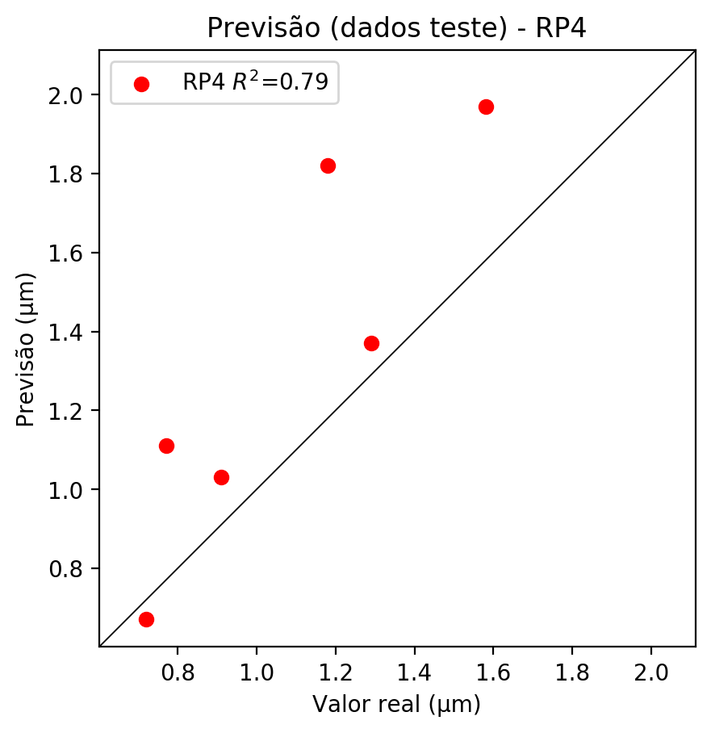

**Dados de treino**

* Erro relativo médio: 0.0
* Coeficiente de correlação: 1.0
* Coeficiente de determinação: 1.0
* MSE: 0.0
* RMSE: 0.0

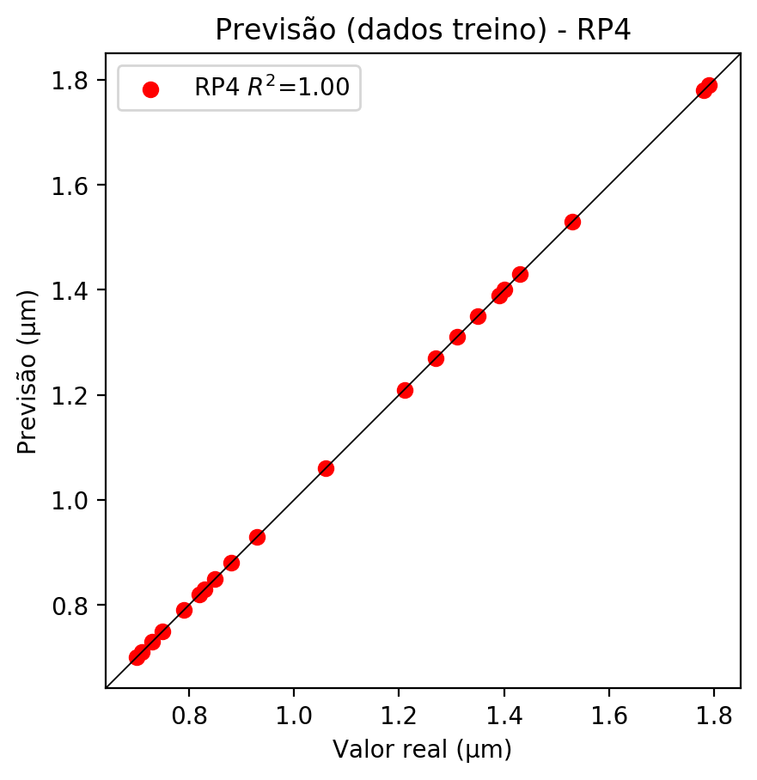

# Geral

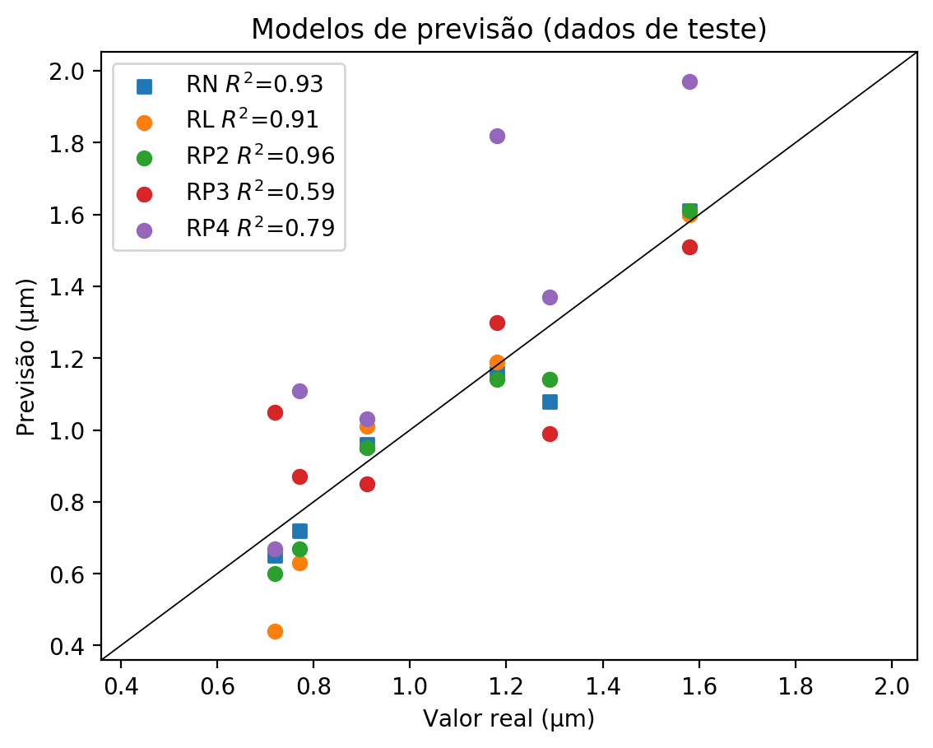

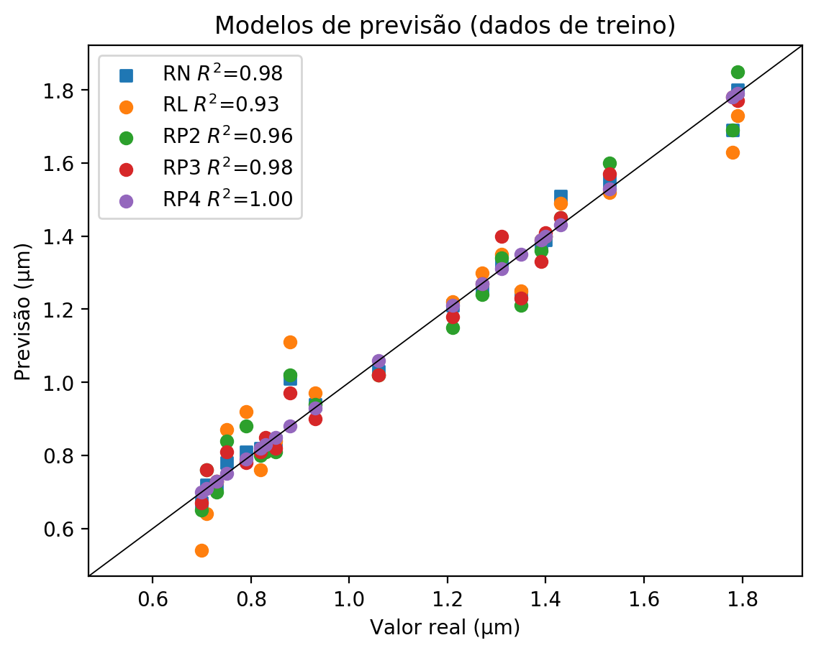

**Dados de teste**

|  |  |  |  |  |  |  |  |  |  |  |
| --- | --- | --- | --- | --- | --- | --- | --- | --- | --- | --- |
| Valor real | RN Previsto | RN Erro (%) | RL Previsto | RL Erro (%) | RP2 Previsto | RP2 Erro (%) | RP3 Previsto | RP3 Erro (%) | RP4 Previsto | RP4 Erro (%) |
| 0.72 | 0.65 | 9.72 | 0.44 | 38.89 | 0.6 | 16.67 | 1.05 | 45.83 | 0.67 | 6.94 |
| 1.58 | 1.61 | 1.9 | 1.6 | 1.27 | 1.61 | 1.9 | 1.51 | 4.43 | 1.97 | 24.68 |
| 1.18 | 1.16 | 1.69 | 1.19 | 0.85 | 1.14 | 3.39 | 1.3 | 10.17 | 1.82 | 54.24 |
| 1.29 | 1.08 | 16.28 | 1.14 | 11.63 | 1.14 | 11.63 | 0.99 | 23.26 | 1.37 | 6.2 |
| 0.77 | 0.72 | 6.49 | 0.63 | 18.18 | 0.67 | 12.99 | 0.87 | 12.99 | 1.11 | 44.16 |
| 0.91 | 0.96 | 5.49 | 1.01 | 10.99 | 0.95 | 4.4 | 0.85 | 6.59 | 1.03 | 13.19 |

**Dados de treino**

|  |  |  |  |  |  |  |  |  |  |  |
| --- | --- | --- | --- | --- | --- | --- | --- | --- | --- | --- |
| Valor real | RN Previsto | RN Erro (%) | RL Previsto | RL Erro (%) | RP2 Previsto | RP2 Erro (%) | RP3 Previsto | RP3 Erro (%) | RP4 Previsto | RP4 Erro (%) |
| 1.53 | 1.55 | 1.31 | 1.52 | 0.65 | 1.6 | 4.58 | 1.57 | 2.61 | 1.53 | 0.0 |
| 1.06 | 1.03 | 2.83 | 1.02 | 3.77 | 1.02 | 3.77 | 1.02 | 3.77 | 1.06 | 0.0 |
| 1.35 | 1.24 | 8.15 | 1.25 | 7.41 | 1.21 | 10.37 | 1.23 | 8.89 | 1.35 | 0.0 |
| 1.39 | 1.38 | 0.72 | 1.39 | 0.0 | 1.36 | 2.16 | 1.33 | 4.32 | 1.39 | 0.0 |
| 1.27 | 1.26 | 0.79 | 1.3 | 2.36 | 1.24 | 2.36 | 1.27 | 0.0 | 1.27 | 0.0 |
| 0.71 | 0.72 | 1.41 | 0.64 | 9.86 | 0.76 | 7.04 | 0.76 | 7.04 | 0.71 | 0.0 |
| 0.88 | 1.01 | 14.77 | 1.11 | 26.14 | 1.02 | 15.91 | 0.97 | 10.23 | 0.88 | 0.0 |
| 1.79 | 1.8 | 0.56 | 1.73 | 3.35 | 1.85 | 3.35 | 1.77 | 1.12 | 1.79 | 0.0 |
| 1.78 | 1.69 | 5.06 | 1.63 | 8.43 | 1.69 | 5.06 | 1.78 | 0.0 | 1.78 | 0.0 |
| 0.83 | 0.82 | 1.2 | 0.81 | 2.41 | 0.81 | 2.41 | 0.85 | 2.41 | 0.83 | 0.0 |
| 0.79 | 0.81 | 2.53 | 0.92 | 16.46 | 0.88 | 11.39 | 0.78 | 1.27 | 0.79 | 0.0 |
| 0.75 | 0.78 | 4.0 | 0.87 | 16.0 | 0.84 | 12.0 | 0.81 | 8.0 | 0.75 | 0.0 |
| 1.31 | 1.33 | 1.53 | 1.35 | 3.05 | 1.34 | 2.29 | 1.4 | 6.87 | 1.31 | 0.0 |
| 0.85 | 0.84 | 1.18 | 0.84 | 1.18 | 0.81 | 4.71 | 0.82 | 3.53 | 0.85 | 0.0 |
| 0.82 | 0.82 | 0.0 | 0.76 | 7.32 | 0.8 | 2.44 | 0.81 | 1.22 | 0.82 | 0.0 |
| 1.43 | 1.51 | 5.59 | 1.49 | 4.2 | 1.45 | 1.4 | 1.45 | 1.4 | 1.43 | 0.0 |
| 0.73 | 0.72 | 1.37 | 0.73 | 0.0 | 0.7 | 4.11 | 0.73 | 0.0 | 0.73 | 0.0 |
| 0.7 | 0.67 | 4.29 | 0.54 | 22.86 | 0.65 | 7.14 | 0.67 | 4.29 | 0.7 | 0.0 |
| 1.4 | 1.39 | 0.71 | 1.4 | 0.0 | 1.4 | 0.0 | 1.41 | 0.71 | 1.4 | 0.0 |
| 1.21 | 1.21 | 0.0 | 1.22 | 0.83 | 1.15 | 4.96 | 1.18 | 2.48 | 1.21 | 0.0 |
| 0.93 | 0.94 | 1.08 | 0.97 | 4.3 | 0.94 | 1.08 | 0.9 | 3.23 | 0.93 | 0.0 |